**LAPORAN HACKERRANK  
MATA KULIAH PEMROGRAMAN WEB**



Dibuat oleh:

Natanael Chrisanta R. - 17051204027 - 2017

**S1 PRODI TEKNIK INFORMATIKA**

**JURUSAN TEKNIK INFORMATIKA**

**FAKULTAS TEKNIK**

**UNIVERSITAS NEGERI SURABAYA**

**2019**

1. Point

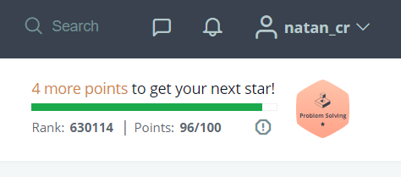

1. Problem Solved

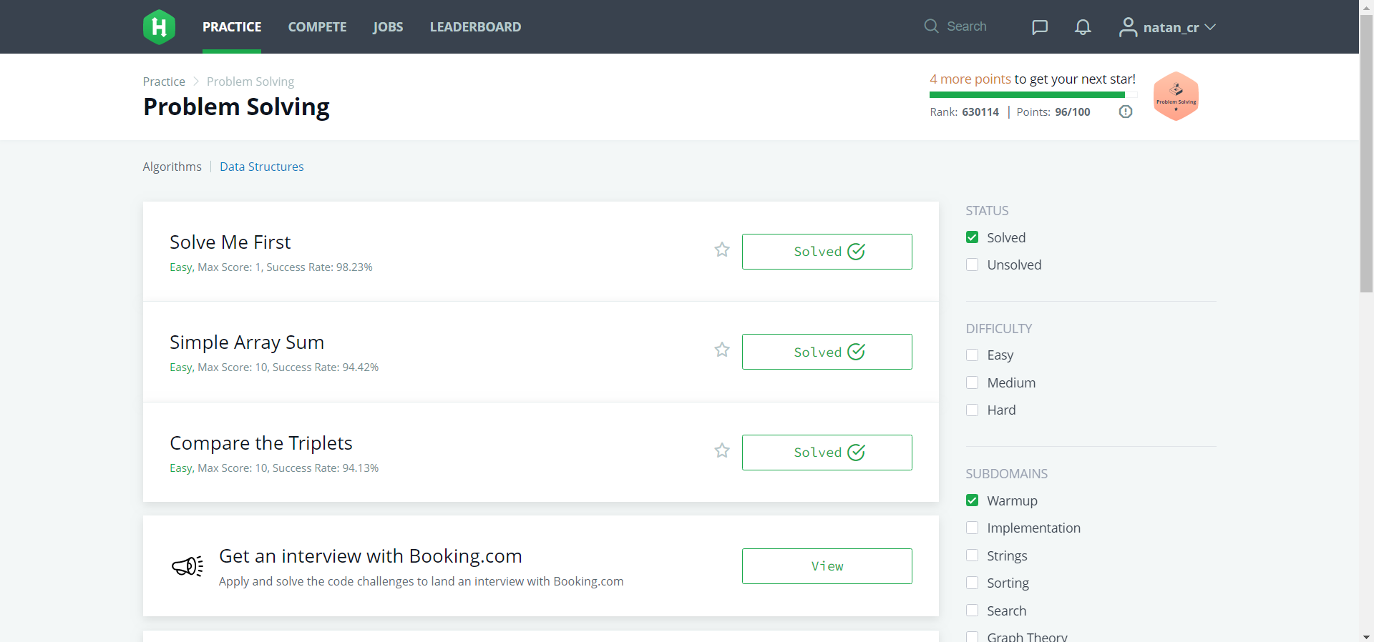

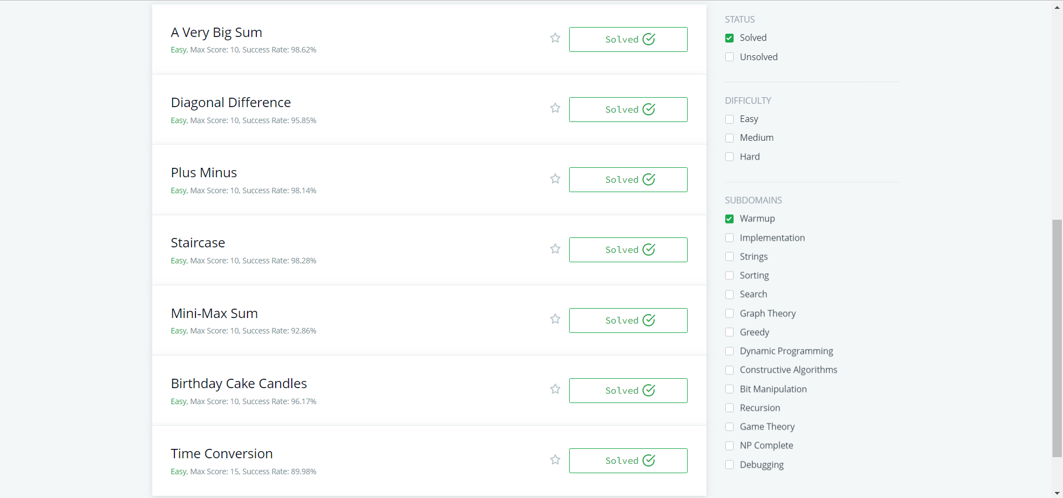

1. Source Code

**Solve Me First**

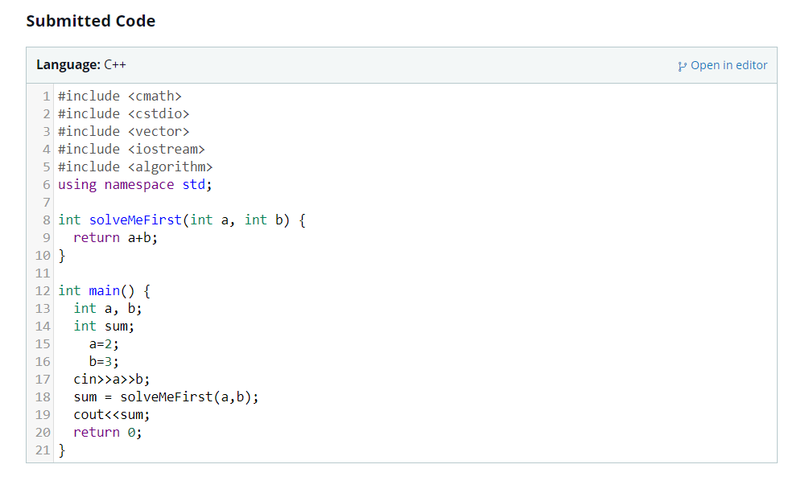

**Simple Array Sum**

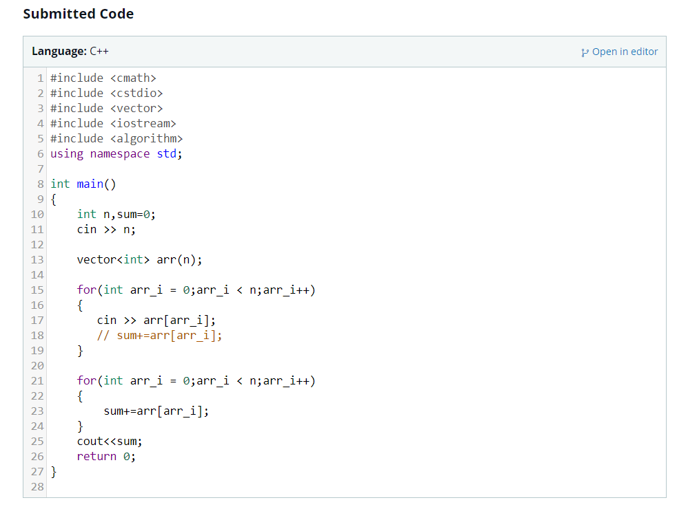

**Compare The Triplets**

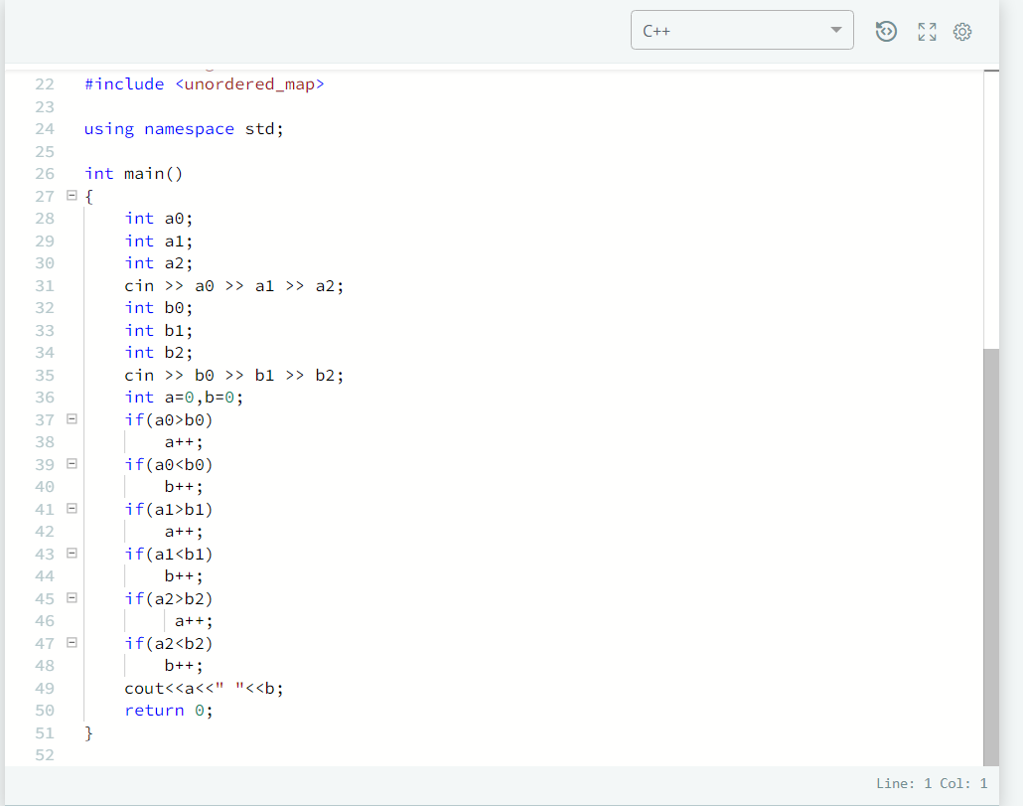

**A Very Big Sum**

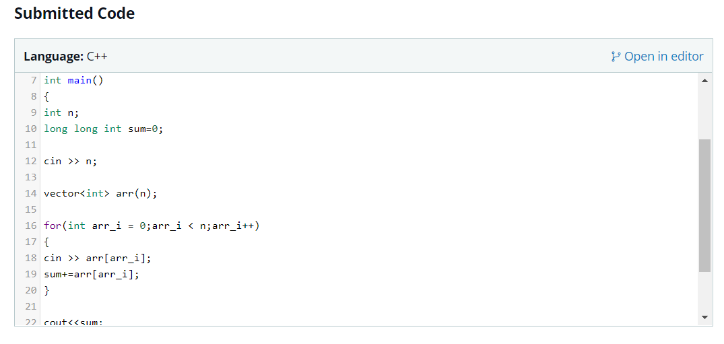

**Diagonal Difference**

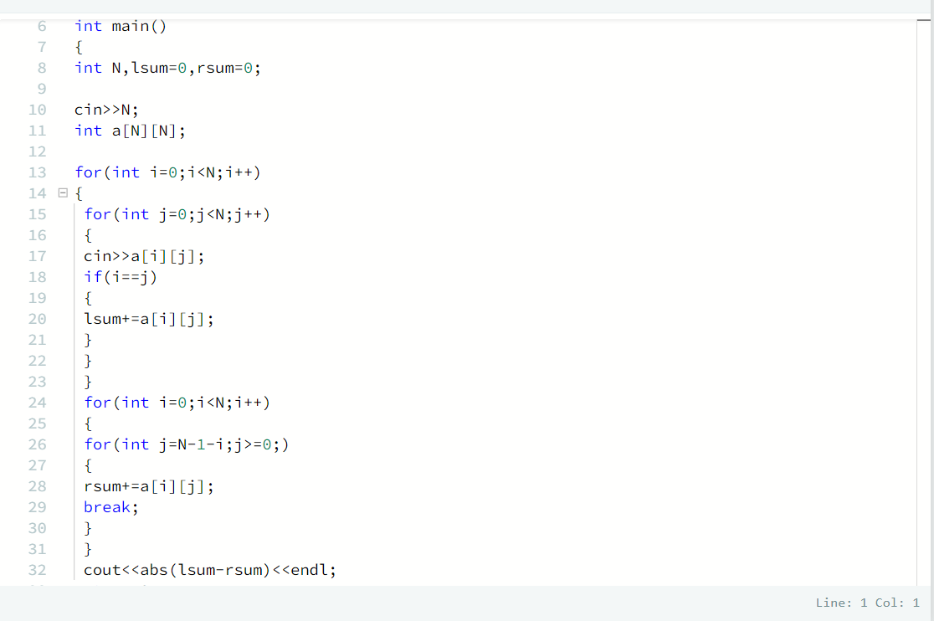

**Plus Minus**

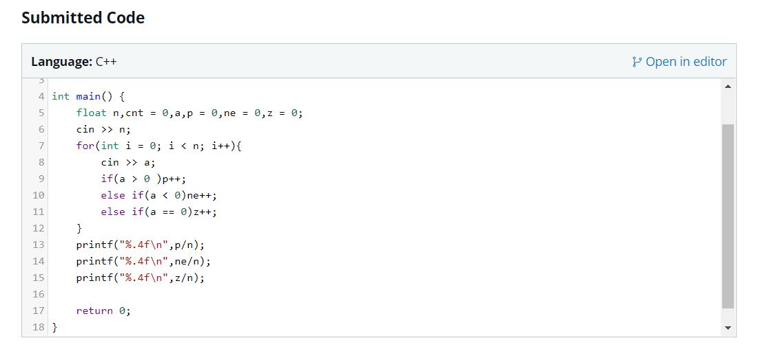

**Staircase**

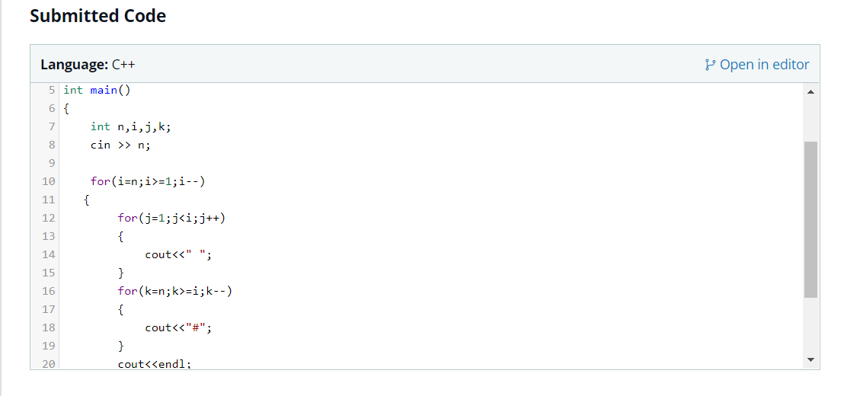

**Mini-Max Sum**

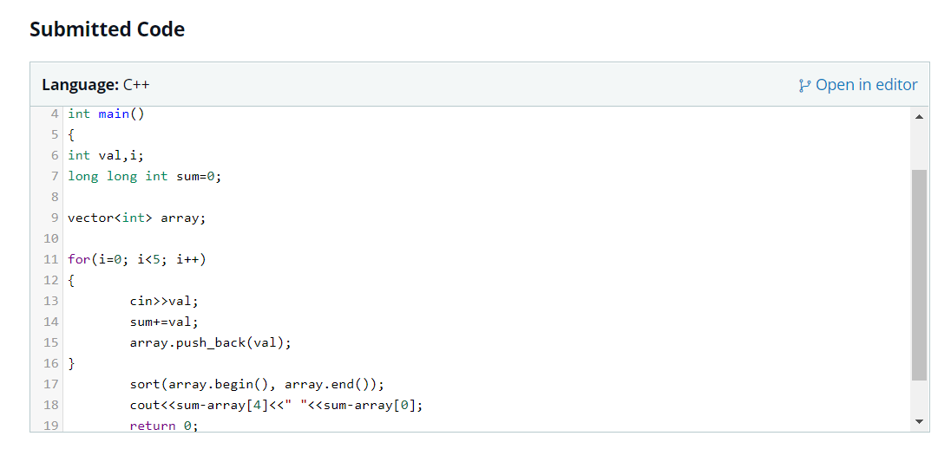

**Birthday Cake Candles**

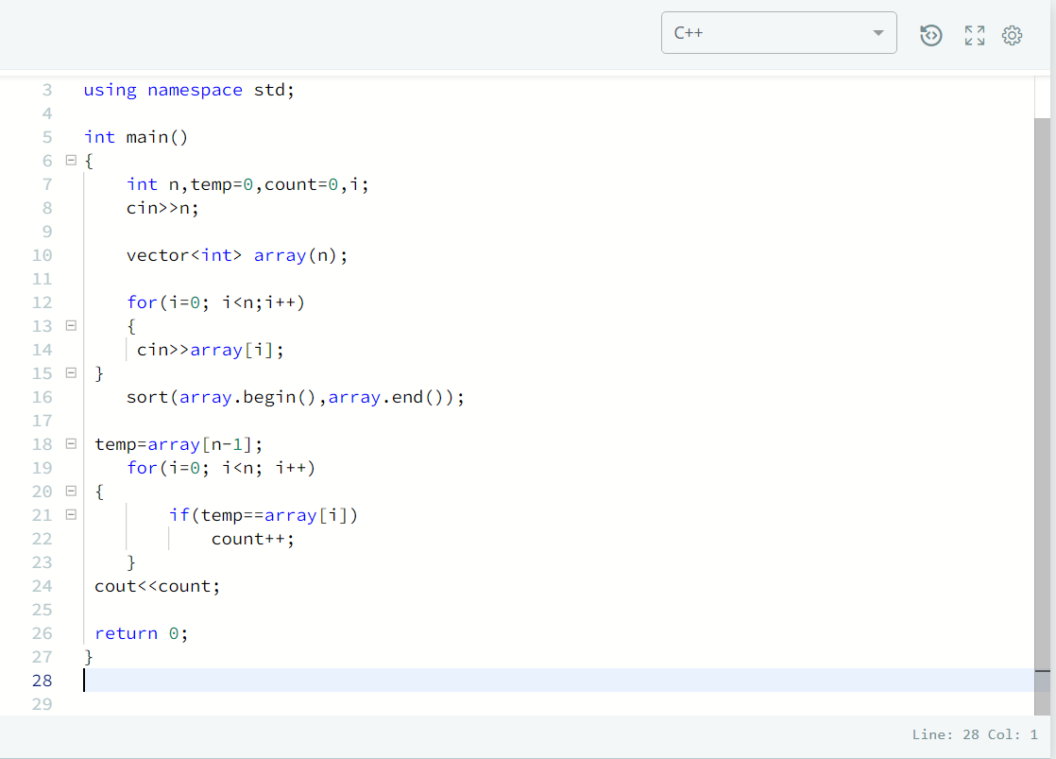

**Time Conversion**

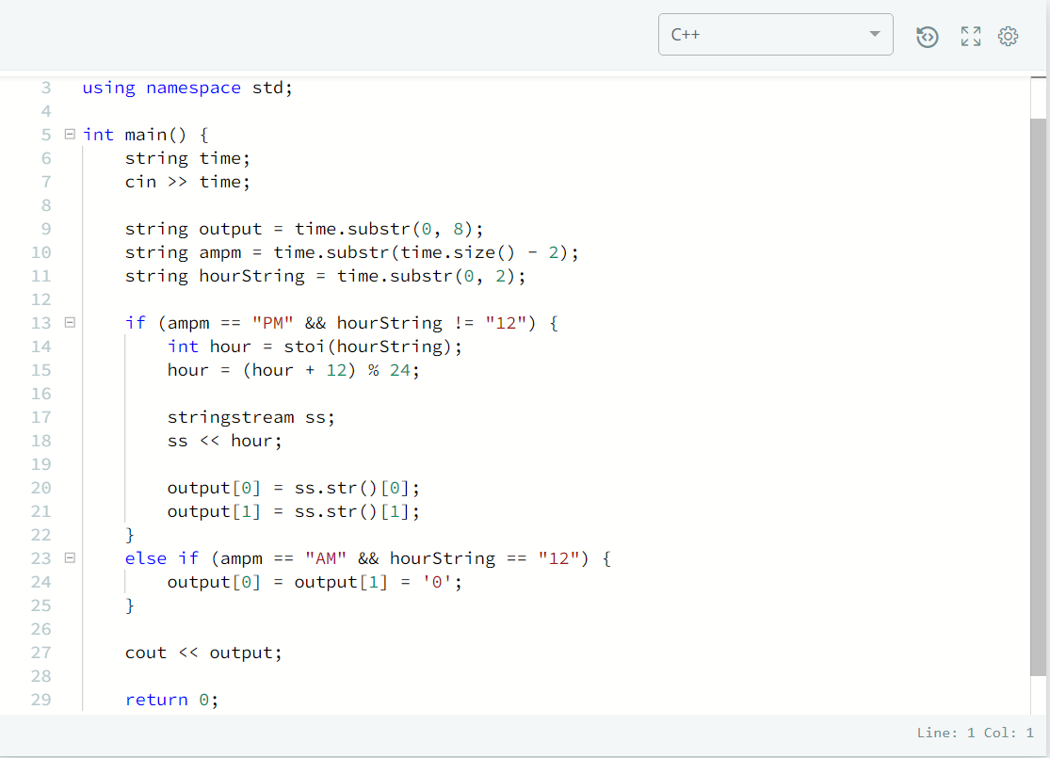

1. Submission

